**PROJECT DEVELOPMENT PHASE**

**SPRINT-4**

|  |  |
| --- | --- |
| Date | 18 November 2022 |
| Team ID | PNT2022TMID45665 |
| Project Name | Natural Disaster Intensity Analysis and Classification using Artificial Intelligence |

***INTEGRATE THE WEB APP WITH AI MODEL:***

After creating the Model, the Model should be integrated with the web app using the Flask application. The coding part is named as app.py and it will be running in the localhost through the generated link. By navigating the localhost the webpage will be visible.

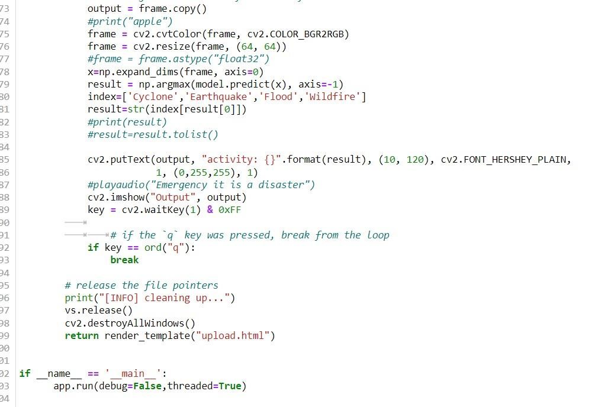

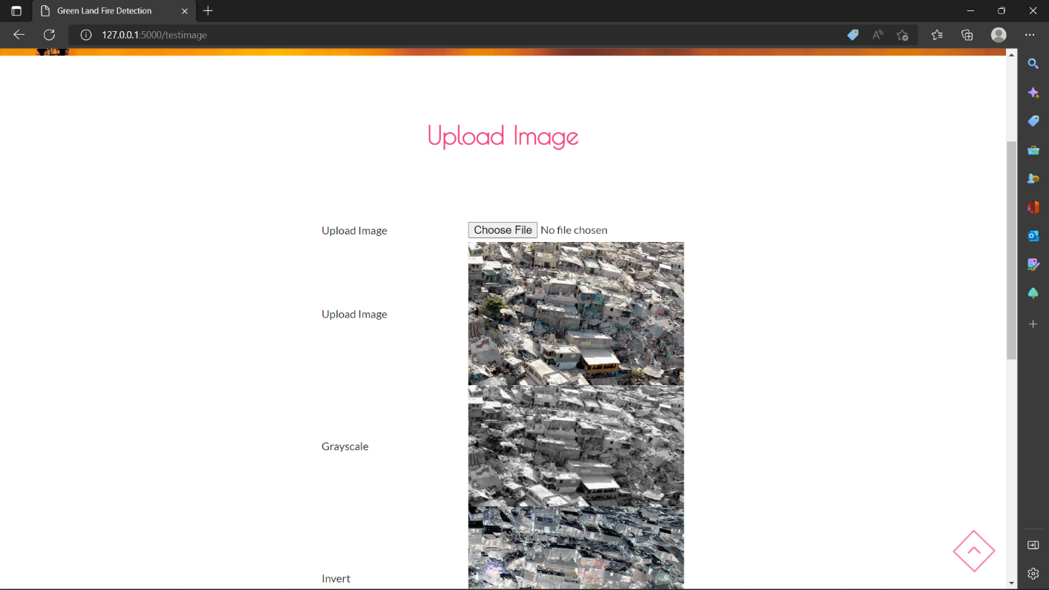

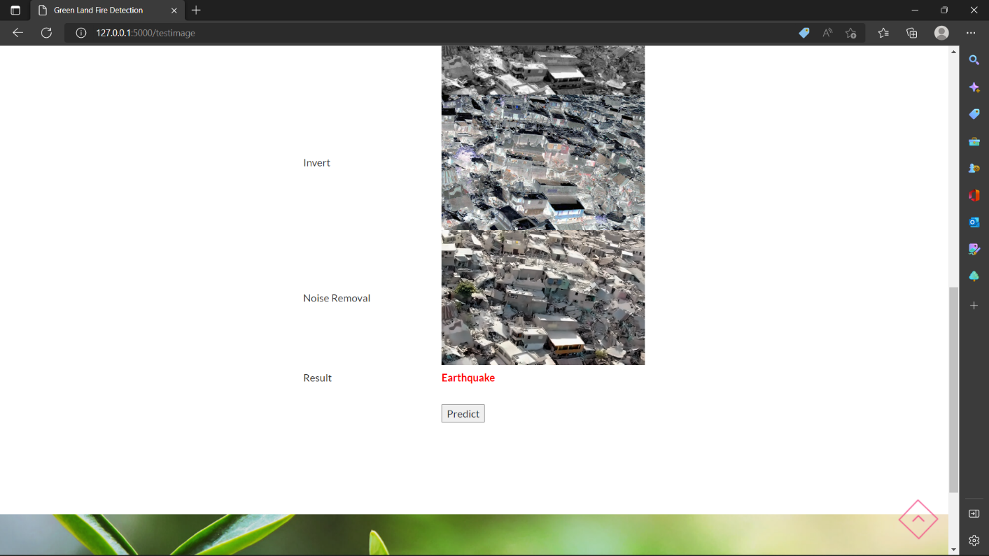

***REGISTER FOR IBM CLOUD:***

Registering IBM Cloud for deploying the model through the Flask application. The IBM Cloud account is created for all the team members.

Team Leader – Praveen Kumar:

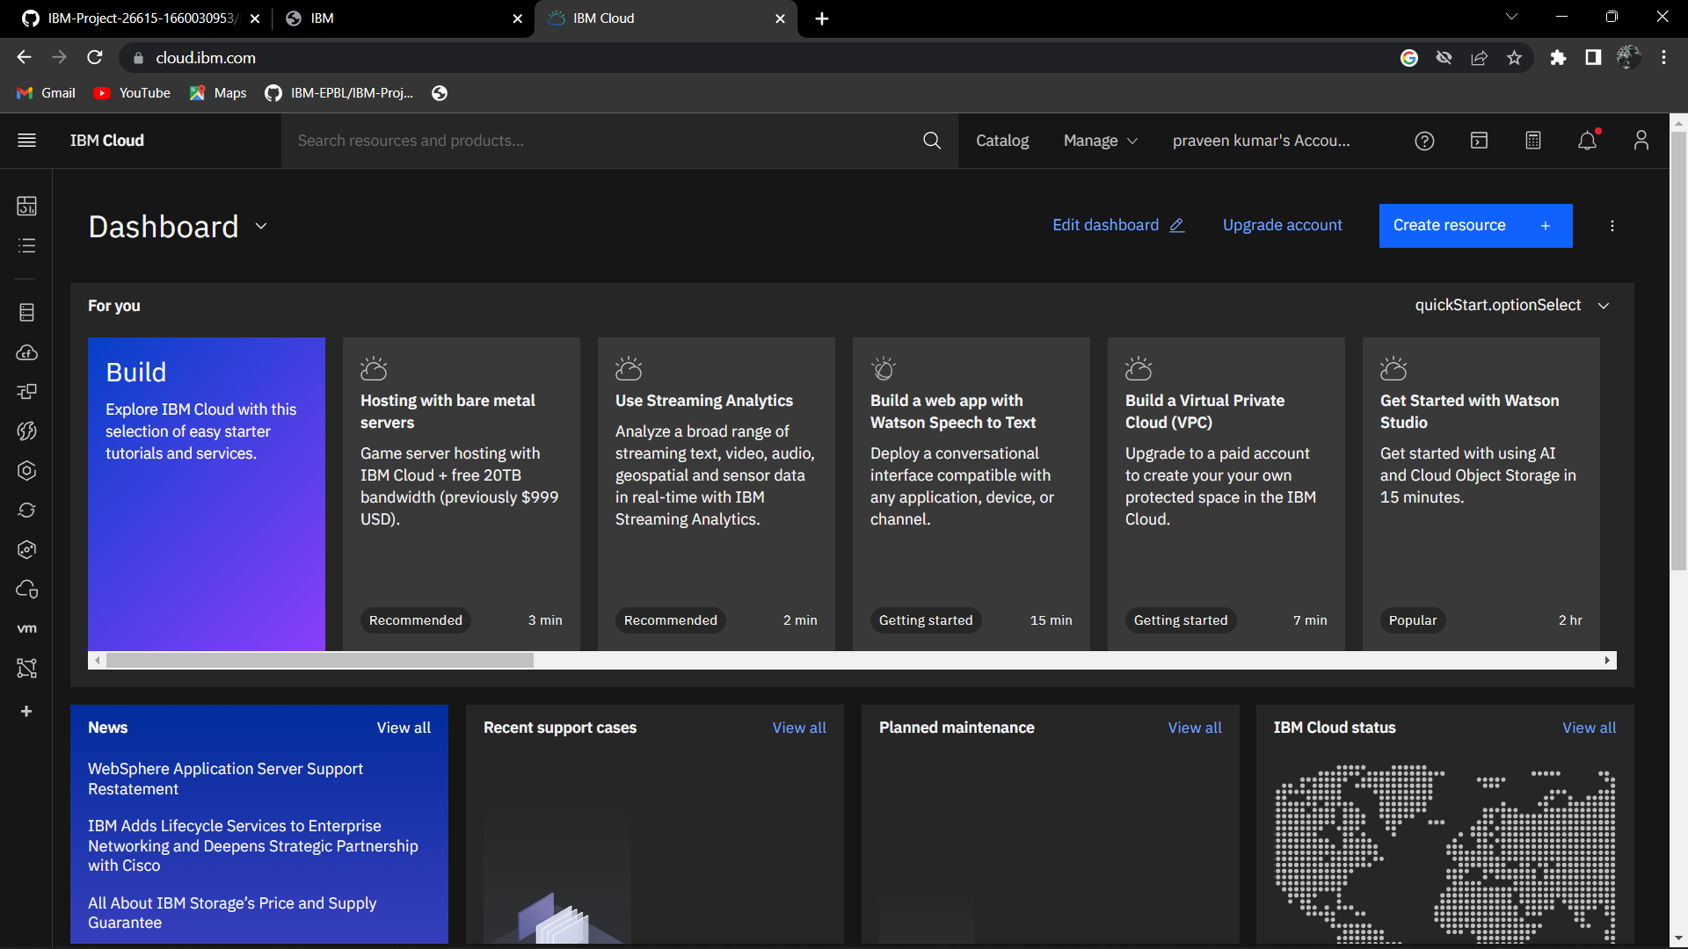

Member -1- Balaji:

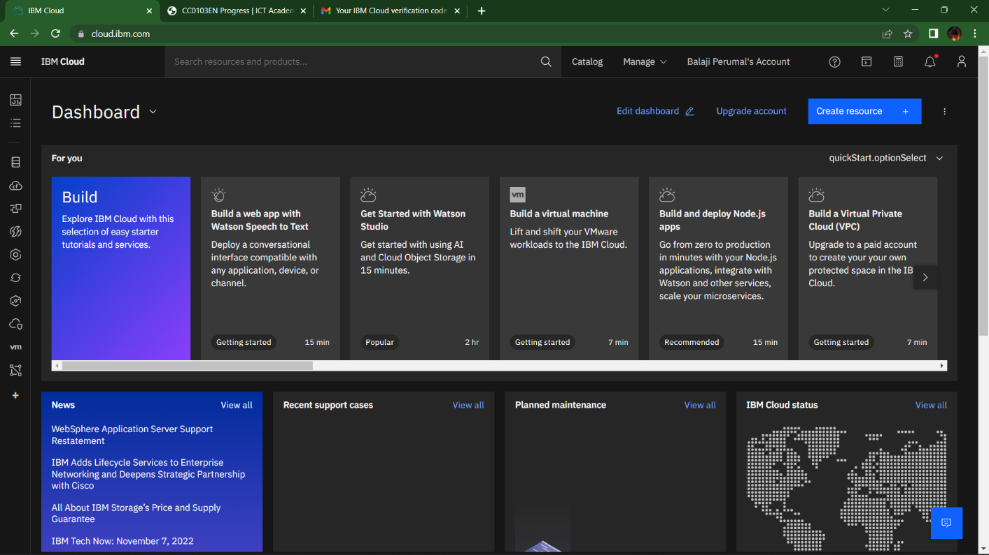

Member – 2 – Karthik:

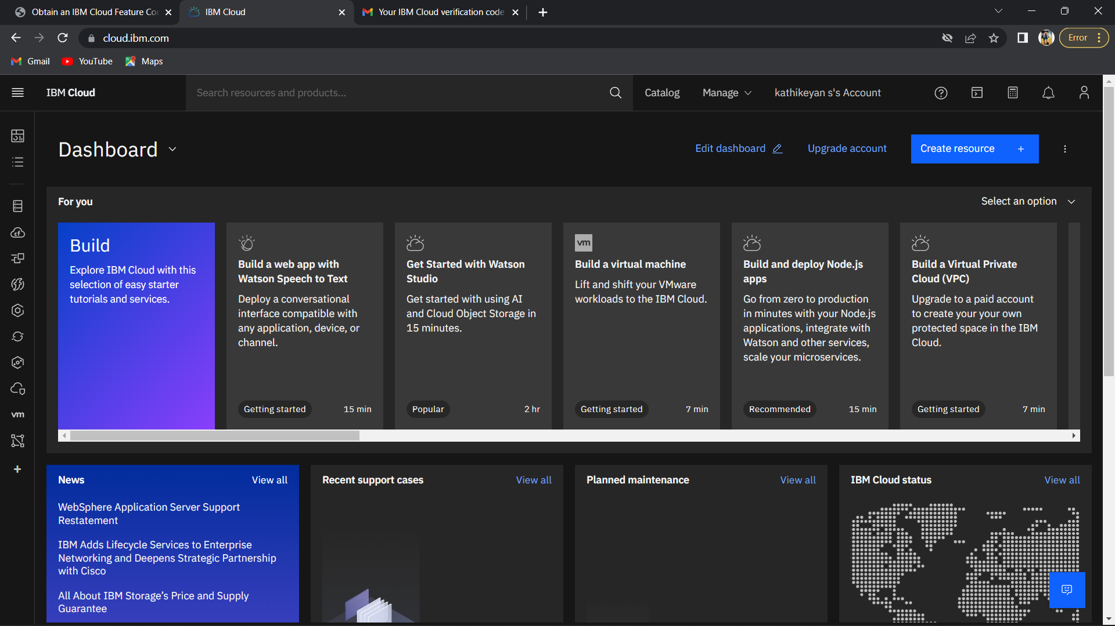

Member-3-Mahamalini:

